**Experiment 1.2**

**Student Name: Yash Gupta UID: 20BCS5009**

**Branch: BE-CSE Section/Group:20BCS_DM-716 B**

**Semester: 6 Date of Performance:**

**Subject Name: MAD LAB Subject Code: 20CSP_356**

## Aim:

To design an android application to display Hello World.

## Objective:

The objective is to know how to show Hello World on the application.

## Code and output:

## Create a new project

## Hello Android Project

## Choose Blank Activity

## Hello Android Project

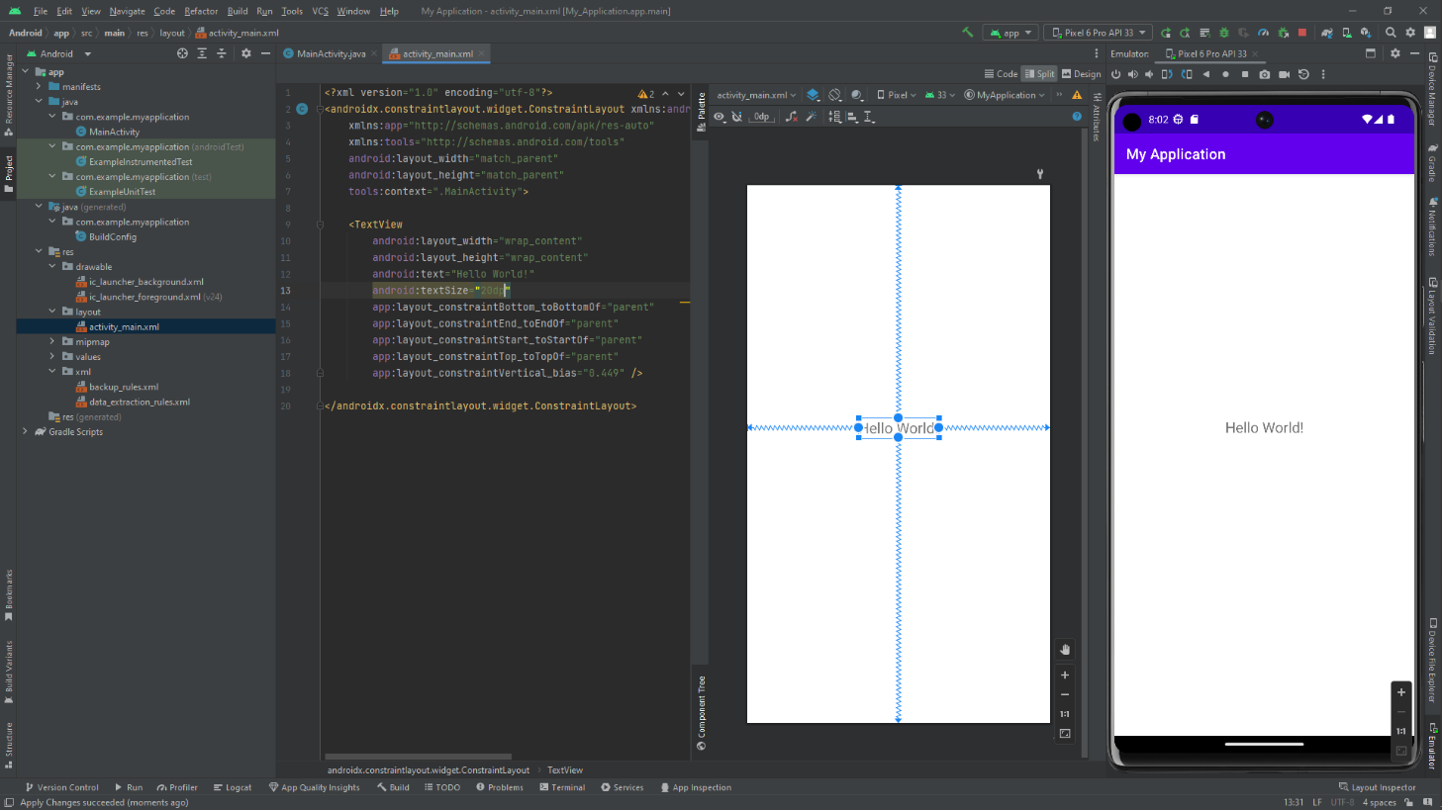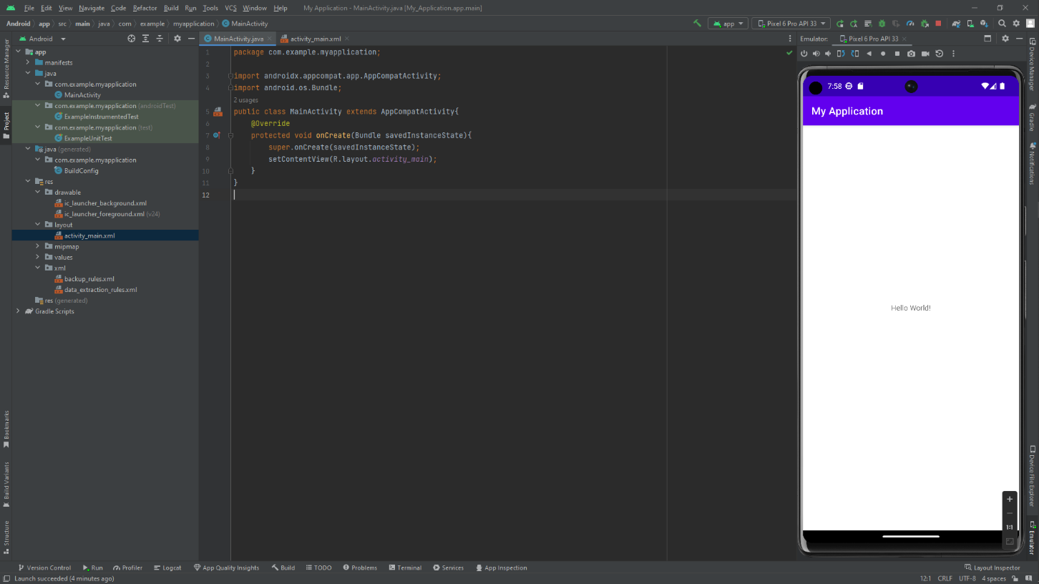package com.example.myapplication;  
  
import androidx.appcompat.app.AppCompatActivity;  
import android.os.Bundle;  
public class MainActivity extends AppCompatActivity{  
 @Override  
 protected void onCreate(Bundle savedInstanceState){  
 super.onCreate(savedInstanceState);  
 setContentView(R.layout.*activity_main*);  
 }  
}